**Assignment -2**

Data Analytics

|  |  |
| --- | --- |
| Assignment Date | 29 September 2022 |
| Student Name | Ms.P.sabitha |
| Student Roll Number | 19ITA47 |
| Maximum Marks | 2 Marks |

**Dashboard:**

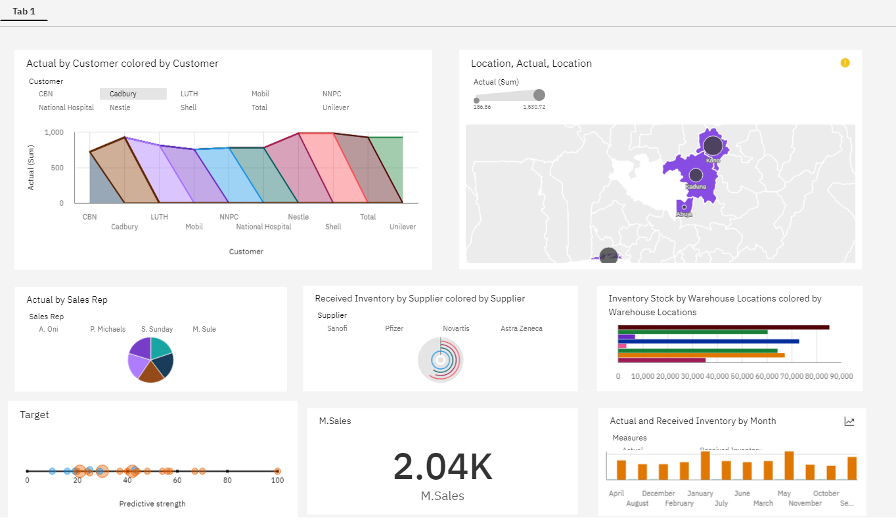

**Link:**

<https://us3.ca.analytics.ibm.com/bi/?perspective=dashboard&pathRef=.my_folders%2FAssignment-2%2FPharma%2BMonthly%2BSales%2BAnalysis%2BCustom%2BDashboard&action=view&mode=dashboard&subView=model0000018384da2ec4_00000000>

**Question-1:**

Sales By Customer.

|  |
| --- |
| **Solution:** |

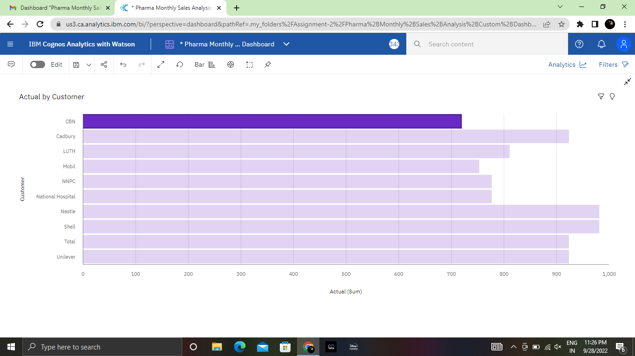

**Question-2:**

Sales By Location.

|  |
| --- |
| **Solution:** |

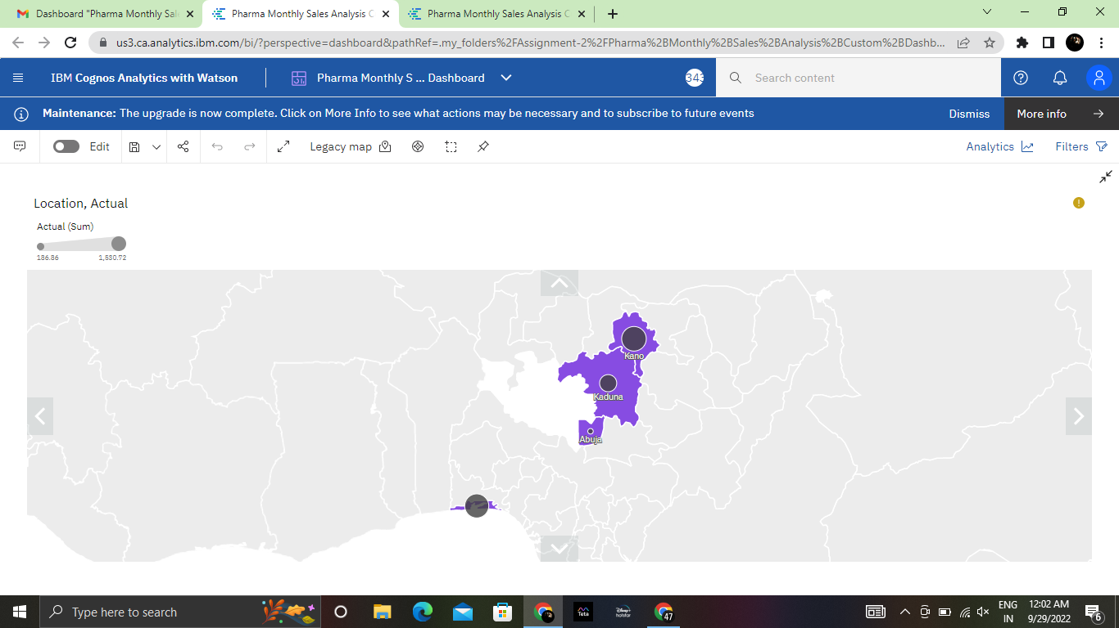

**Question-3:**

Sales By Sales Representative.

|  |
| --- |
| **Solution:** |

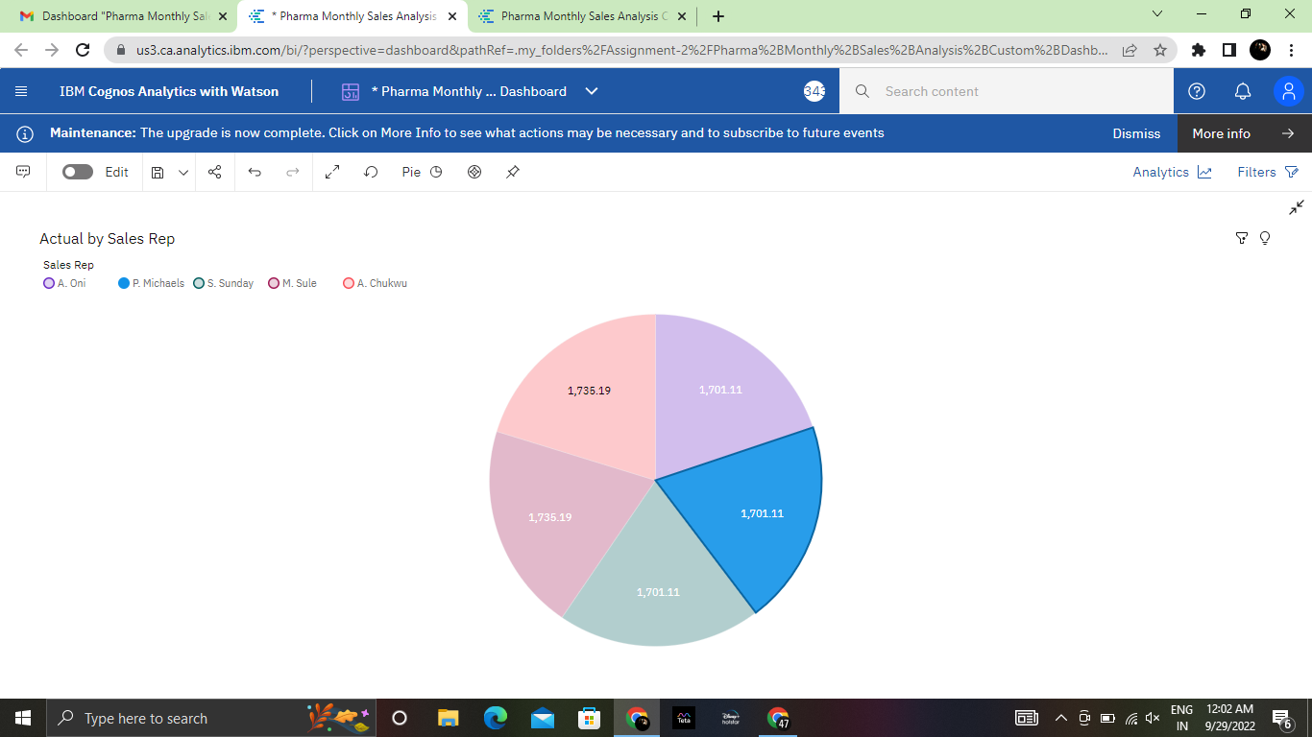

**Question-4:**

Received Inventory From Supplier.

|  |
| --- |
| **Solution:** |

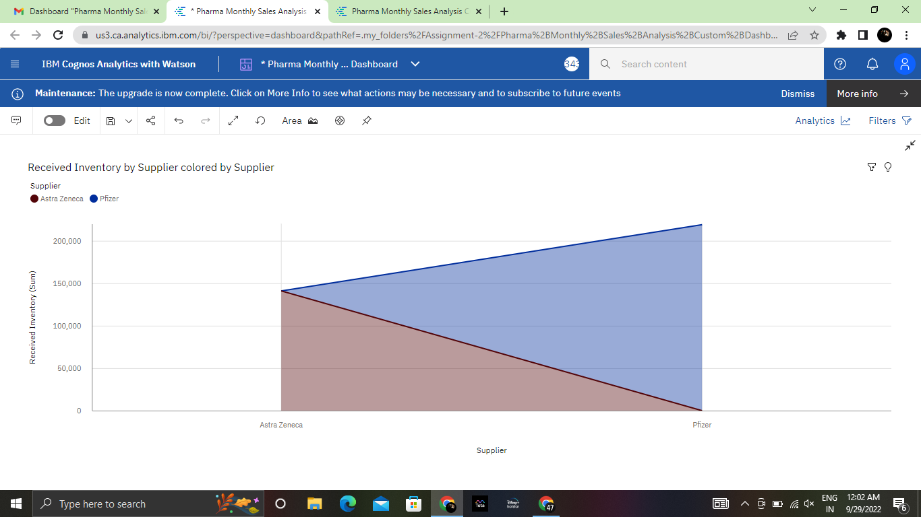

**Question-5:**

Inventory Stock for Warehouse Locations.

|  |
| --- |
| **Solution:** |

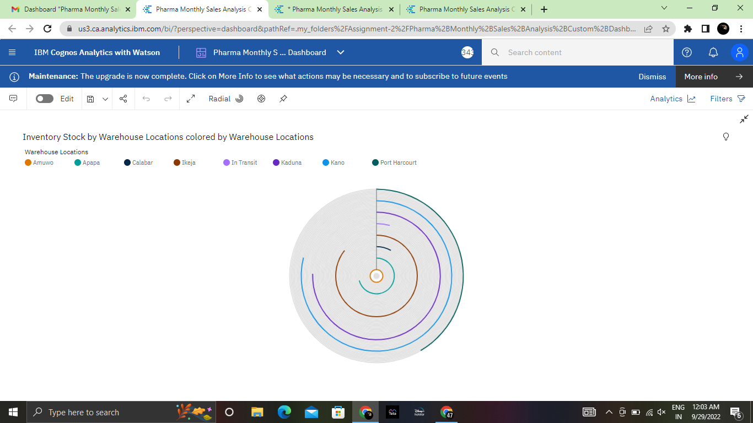

**Question-6:**

Sales Trend.

|  |
| --- |
| **Solution:** |
|  |

**Question-7:**

Monthly Sales.

|  |
| --- |
| **Solution:** |
| **Question-8:**  Actual and Received Inventory by Month.  **Solution:**     |  | | --- | |  | |